SOP-PR-014
Purchase Requisition to Purchase Order
Standard Operating Procedure — Indirect Procurement
Document owner | Head of Indirect Procurement | Version | 4.2
Effective date | 01 March 2026 | Next review | 01 March 2027
Classification | Internal | Applies to | All UK entities

1. Purpose
This procedure defines how an employee requests goods or services, how the request is approved against delegated financial authority, and how an approved request becomes a purchase order. It exists so that committed spend is authorised before an order reaches a supplier.

2. Scope
This procedure covers indirect goods and services purchased through Coupa by any UK entity. The following are explicitly out of scope:
- Direct materials purchased under a framework agreement, covered by SOP-PR-002.
- Employee expenses reimbursed after the event, covered by SOP-FN-030.
- Intercompany recharges, which do not raise a purchase order.

3. Definitions
Term | Meaning
PR | Purchase requisition — the internal request to buy, raised in Coupa.
PO | Purchase order — the commitment sent to the supplier from SAP S/4HANA.
ASL | Approved Supplier List, maintained by Procurement in SAP S/4HANA.
DFA | Delegated Financial Authority — the value a role may approve.

4. Roles and responsibilities
Role | Responsibility
Requester | Raises the requisition, attaches the supplier quote and confirms the cost centre.
Finance Manager | Reviews and approves requisitions above the auto-approval threshold within their DFA.
Finance Director | Approves requisitions above £25,000 as a second approval.
Procurement Officer | Vets any supplier not on the ASL and raises the purchase order in SAP S/4HANA.
Accounts Payable | Matches the supplier invoice to the purchase order. Not part of this procedure.

5. Procedure
5.1 The requester raises a purchase requisition in Coupa, entering the description, quantity, required-by date and the cost centre to be charged.
5.2 The requester attaches a valid supplier quote to the requisition. A quote is valid for 90 days from its issue date. A requisition submitted without a quote is returned to the requester by Coupa and does not enter approval.
5.3 Coupa checks the total value of the requisition against the auto-approval threshold. Requisitions of £5,000 or less are approved automatically and pass straight to clause 5.7.
5.4 Requisitions above £5,000 are routed to the Finance Manager for the requesting cost centre. The Finance Manager reviews the business justification and approves or rejects within 2 business days.
5.5 Requisitions above £25,000 require a second approval from the Finance Director after the Finance Manager has approved. Both approvals are recorded in Coupa against the requisition.
5.6 If the Finance Manager rejects the requisition, Coupa notifies the requester with the rejection reason and the requisition is closed. The requester may raise a new requisition addressing the reason given.
5.7 Procurement checks whether the supplier appears on the Approved Supplier List. If the supplier is not on the ASL, the Procurement Officer completes supplier vetting — financial standing, insurance and modern slavery declaration — and adds the supplier to SAP S/4HANA. Vetting is completed within 5 business days.
5.8 The Procurement Officer raises the purchase order in SAP S/4HANA and sends it to the supplier. The PO number is written back to the requisition in Coupa.
5.9 Coupa notifies the requester that the purchase order has been issued, within 1 business day of the PO being raised. A ServiceNow ticket is raised only where the requester disputes the outcome.
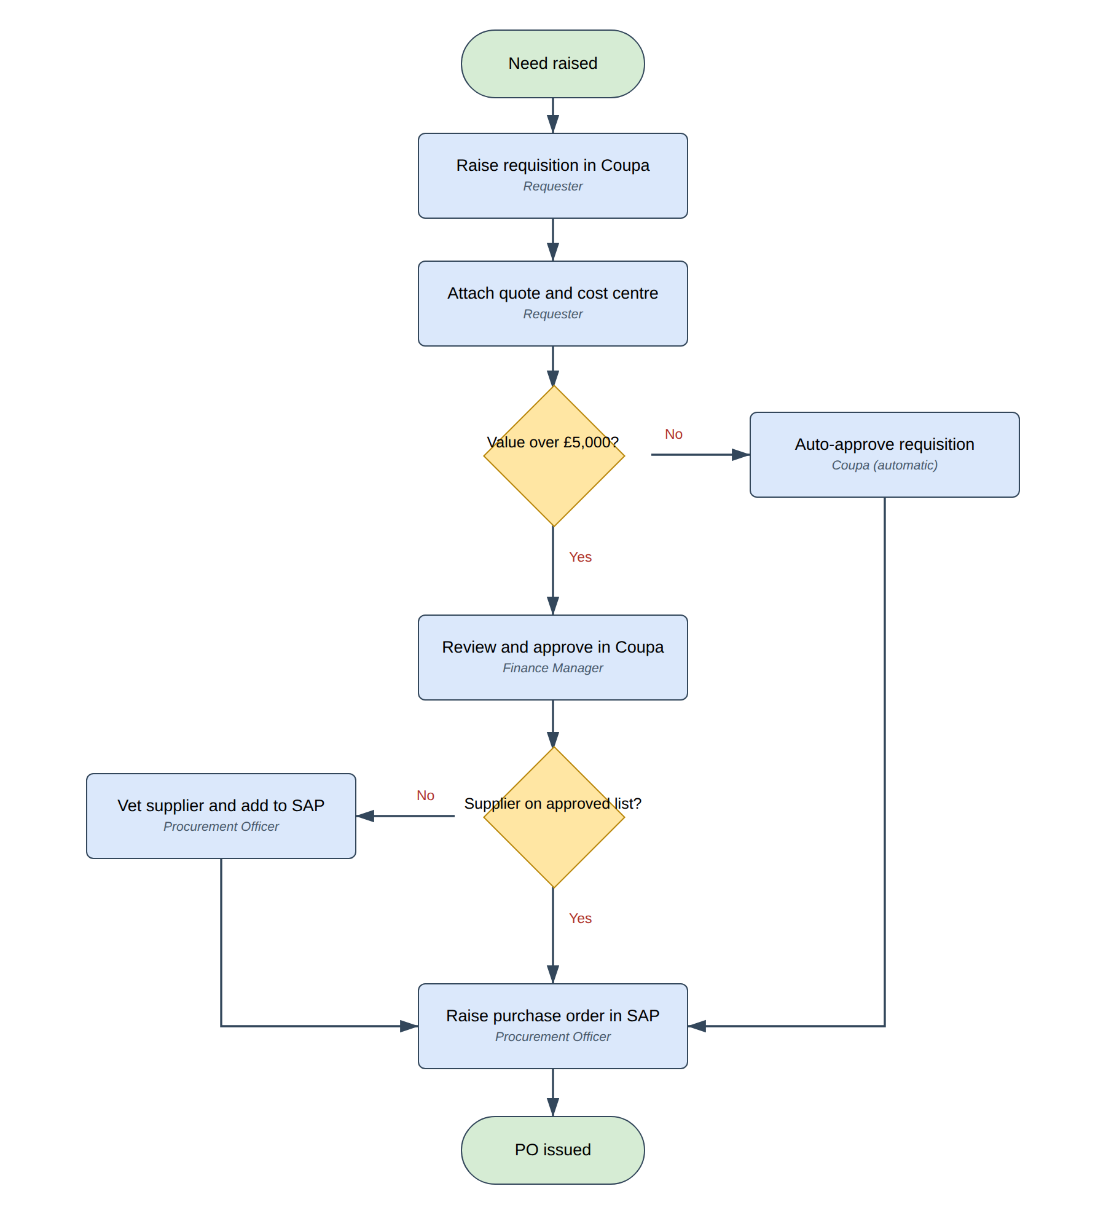
Figure 1 — Purchase requisition approval flow

6. Process steps
Step | Activity | Responsible | System | Input | Output
1 | Raise purchase requisition | Requester | Coupa | Requirement | Draft PR
2 | Attach supplier quote | Requester | Coupa | Supplier quote | Submitted PR
3 | Check approval threshold | Coupa (automatic) | Coupa | Submitted PR | Routing decision
4 | Approve requisition | Finance Manager | Coupa | Submitted PR | Approved PR
5 | Give second approval | Finance Director | Coupa | Approved PR | Approved PR
6 | Vet supplier | Procurement Officer | SAP S/4HANA | Vetting pack | ASL entry
7 | Raise purchase order | Procurement Officer | SAP S/4HANA | Approved PR | Purchase order
8 | Notify requester | Coupa (automatic) | Coupa | Purchase order | Notification

7. Records
Approved requisitions and purchase orders are retained for seven years in line with the Group Records Retention Schedule. Supplier vetting packs are retained for the life of the supplier relationship plus six years.

8. Revision history
Version | Date | Author | Change
4.2 | 01 Mar 2026 | Head of Indirect Procurement | Auto-approval threshold raised to £5,000.
4.1 | 14 Sep 2025 | Procurement Excellence | Added second approval above £25,000.
4.0 | 02 Jan 2025 | Procurement Excellence | Migrated from Ariba to Coupa.

